PRACTICAL 10

**AIM:** Load Testing Using JMeter.

**Step 1:** Right click on the "Test Plan" and add a new thread group: Add -> Threads (Users) -> Thread Group

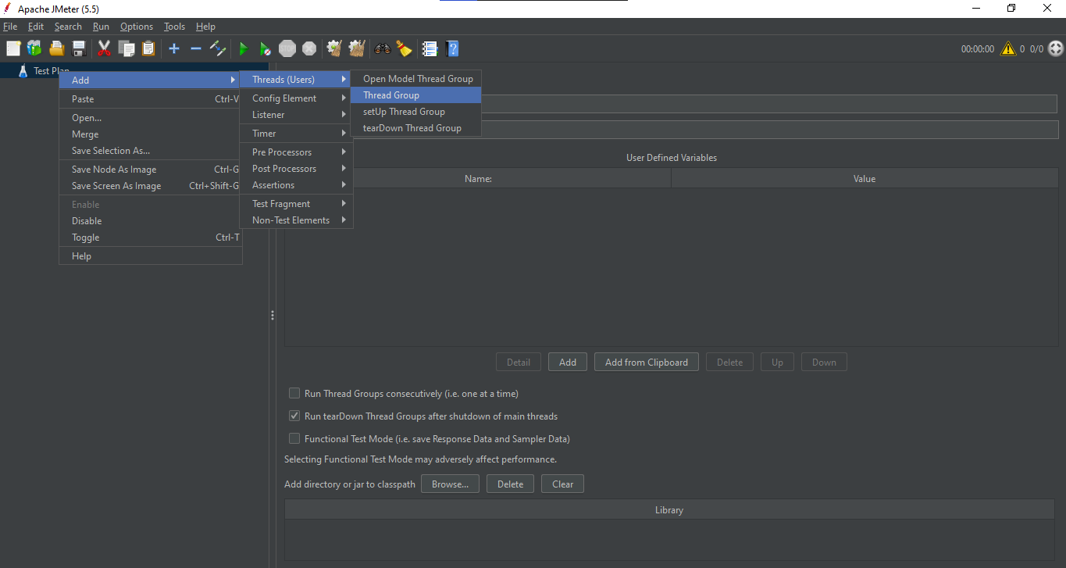

**Step 2:** Thread Group Property Window will be opened, Enter the following Properties.

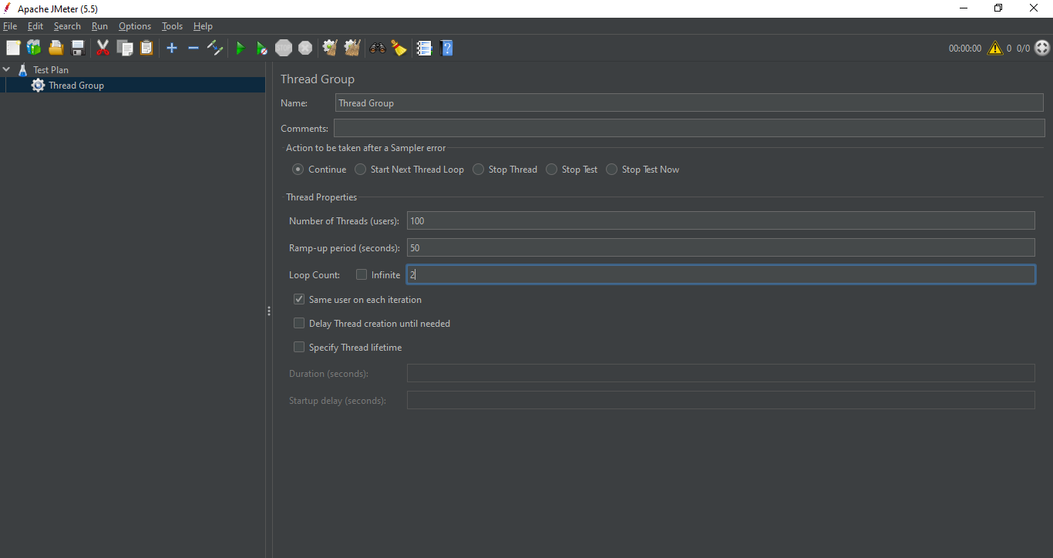

**Step 3:** Right Click on Thread Group then Add🡪Config Element🡪HTTP Request Defaults

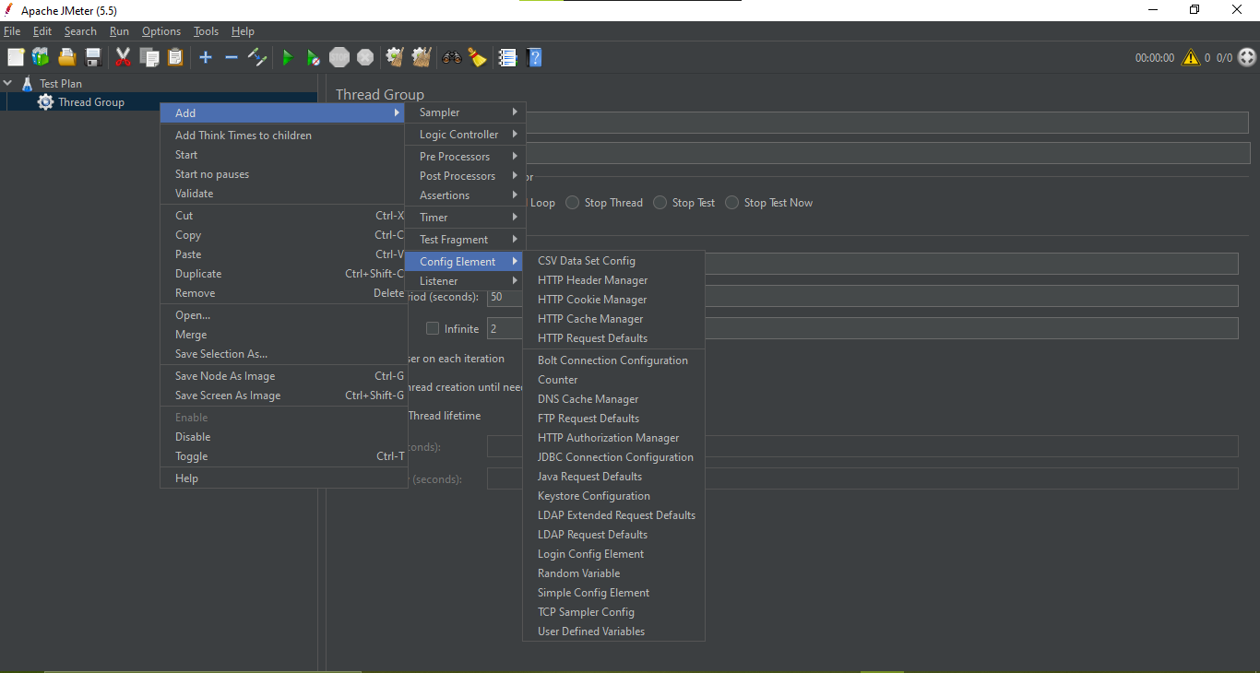

**Step 4:** Enter [www.google.com](http://www.google.com) in the path section, and Port Number as 80.

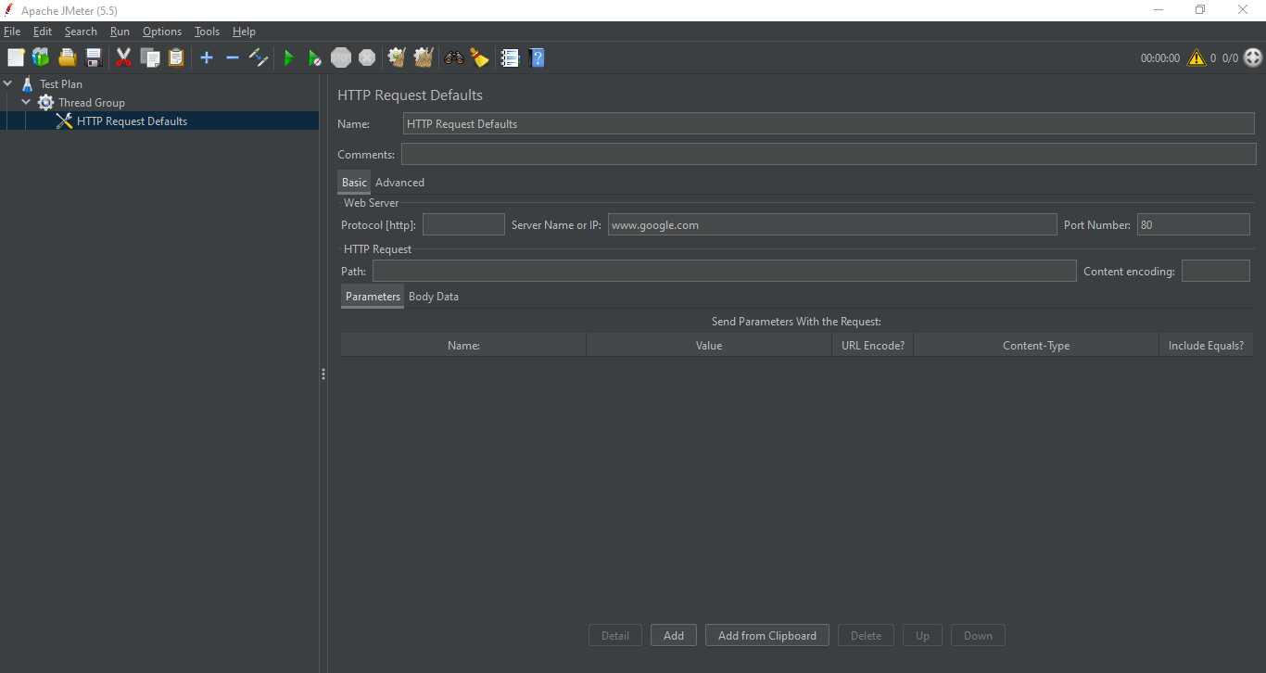

**Step 5:** Right Click on Thread Group 🡪Add🡪Sampler🡪HTTP Request

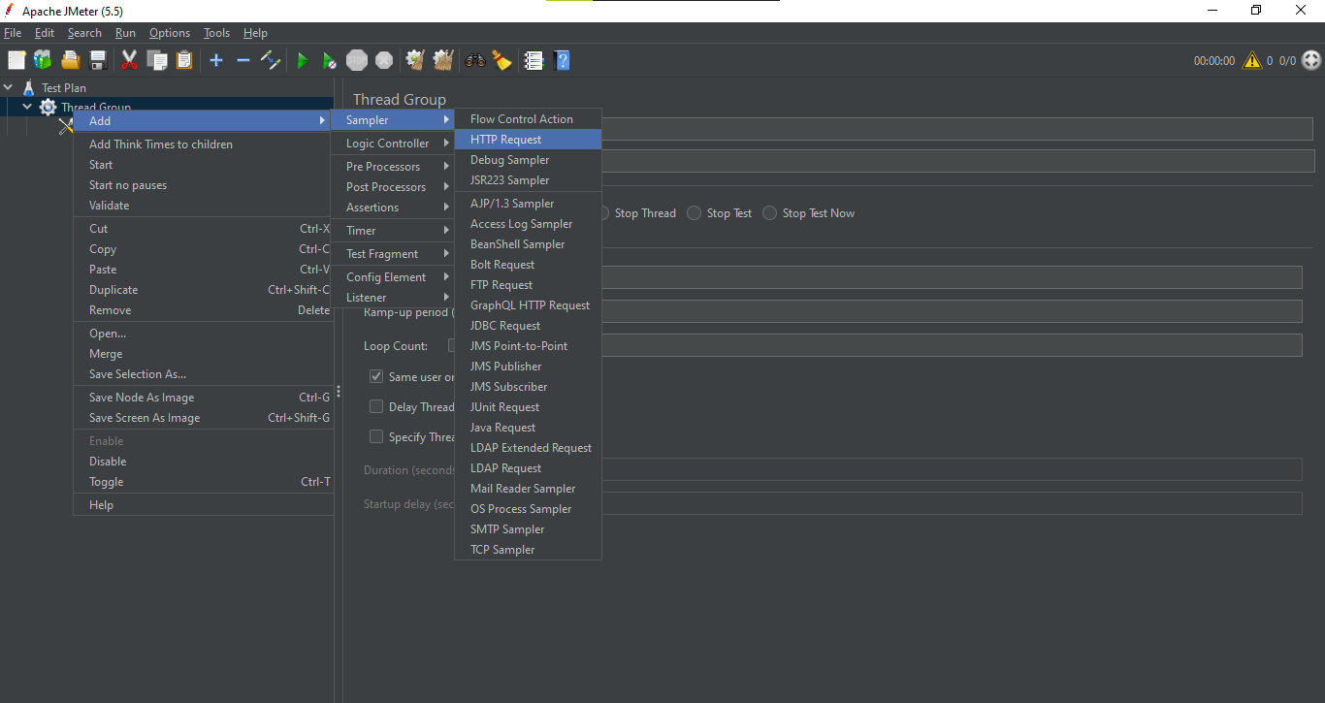

**Step 6:** Type calendar in the Path Section.

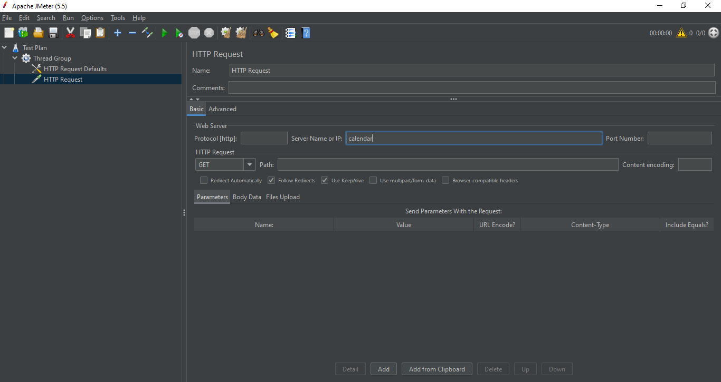

**Step 7:** Right Click on Thread Group🡪Add🡪Listener 🡪Graph Results

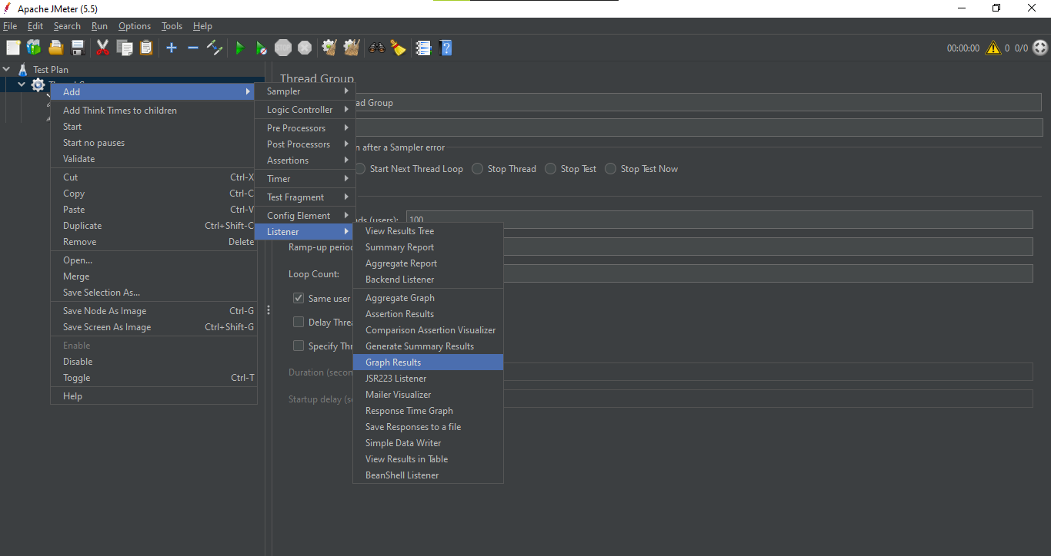

**Step 8:** Save the Test before Running.

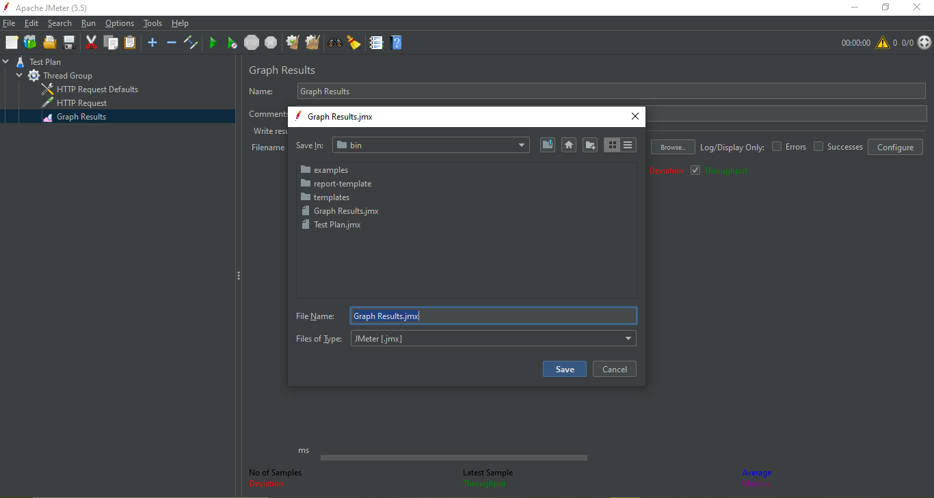

**Step 9:** Run the Test.

